**МРНТИ 68.47.**

***О.Адалқан1*, Г.И. Джаманова1, Ж.М. Байгазакова 1, К. Ю. Дербышев2, М.К. Булатова3***

*1* Non-commercial joint-stock company Shakarim Semey University, Abai region, Semey, Glinka str. 20A, 071412, Kazakhstan,* [*oral.adalkan@mail.ru*](mailto:oral.adalkan@mail.ru)

***2\**** *Agrotechnopark of Non-commercial joint-stock company "Shakarim University of Semey", Abai region, Semey, Glinka str. 20A, 071412, Kazakhstan.*

*3 Republican State Institution State Forest Natural Reserve "Semey Ormany", Semey, St. Tuktabayeva 19 , Kazakhstan.*

**THE EFFECT OF COMPOST WITH THE ADDITION OF PEAT MINERALS ON THE GROWTH OF PINE SEEDLINGS**

***Annotation***

*The article examines the effect of compost with the addition of peat minerals on the growth and survival of seedlings of Scots pine (Pinus sylvestris) in forest nurseries. Studies have shown that the use of organic fertilizers enriched with peat components helps to improve the soil structure, increase the content of humus and trace elements necessary for the full development of the root system. During the experiments, different proportions of compost and peat additives were studied, and a comparative assessment of the growth of seedlings and their biomass was carried out. The results indicate that the combined use of these components increases the survival rate of seedlings by 4.5%, reduces the loss of planting material by 2 times and accelerates plant growth by 3-4 cm. Improved aeration and moisture retention capacity of the soil contributed to an increase in plant resistance to stress factors.*

*Additionally, a phenological analysis showed that seedlings grown with the addition of peat minerals had a more developed root system and actively increased biomass. The results obtained confirm the expediency of using this technology in forest nurseries and reforestation projects, since it not only increases the productivity of seedlings, but also contributes to the creation of environmentally sustainable forest plantations. The developed recommendations can be used to further optimize substrates and improve planting methods, which is especially important in the context of climate change and soil degradation.*

***Keywords:*** *pinus silvestris, seedlings, forest nurseries, compost, peat minerals, fertilizers, organic additives, plant growth, soil fertility, humus, biomass, soil aeration, mineralization, microbiological activity, root nutrition, plant adaptation, stress resistance, innovative fertilizers, forest ecology, soil restoration, soil structure, fertilizer efficiency, accelerated growth, protection from diseases, reforestation, forestry.*

**Purpose of research:** To determine the effect of compost with the addition of peat minerals on the growth and development of pine seedlings in nurseries, as well as to identify the optimal proportions of components to improve survival and accelerate the growth of young trees.

**Research objectives**

1. To study the growth dynamics of pine seedlings with various fertilizer options.

2. To evaluate the effect of fertilizers on plant survival and adaptation.

The effectiveness of reforestation of cuttings and harems, in the absence of seeding agents, can be ensured by artificial reforestation. However, artificial reforestation is possible only if there is a significant amount of standard planting material grown in a specific forest area (subzone), taking into account the requirements of forest-seed zoning. Unfortunately, the cultivation of standard planting material is associated with a number of difficulties. The latter is primarily due to a decrease in soil fertility in forest nurseries, since every year a significant part of the nutrients are removed from the soil with grown seedlings.

Restoration of soil fertility in forest nurseries can be ensured by applying organic fertilizers, growing siderates, as well as applying mineral fertilizers. The introduction of organic fertilizers is hampered by their shortage and, as a result, high cost caused by a sharp reduction in livestock numbers, as well as the complexity of paperwork for the right to extract peat.

In addition, not all areas have peat resources with a high nutrient content.

The soil plays a key role in the development of seedlings, providing them with nutrients, moisture, oxygen and mechanical support. Its composition and properties directly affect the growth rate, survival rate and stability of young trees.

The main soil properties affecting the growth of seedlings are shown in Table 1.

Table 1 - Basic soil properties affecting the growth of pine seedlings

| factor | Influence on the growth of seedlings | Optimal conditions | Ways to improve |
| --- | --- | --- | --- |
| Nutrients (nitrogen, phosphorus, potassium, trace elements) | They ensure growth, strengthen roots, and increase resistance to diseases | Nitrogen (N): 0.5–2%Phosphorus (P₂o₅): 0.3–1%Potassium (K₂O): 0.5–2% | Application of compost, humates, mineral fertilizers |
| Soil structure | Affects rooting, water and air permeability | Loamy, friable, rich in humus | Addition of organic matter (compost, humus), aeration |
| Acidity (pH) | Determines the availability of nutrients | Optimal pH 5.0–6.5 | Acidification by peat, sulfur (at pH > 7.5); liming (at pH < 4.5) |
| Moisture-retaining ability | Disadvantage – slow growth; excess – rotting of the roots | Moderate humidity, good water permeability | Peat, humus, mulching |
| Microorganisms (bacteria, fungi) | They improve mineralization and enhance the immunity of seedlings | High biological activity of the soil | Use of biological products, siderates |
| Soil temperature | It affects root activity and nutrient absorption | Optimally +15...+25°C | Dark mulching, humidity control |
| Salinity | Delays growth, impairs root nutrition | Electrical conductivity < 2 ms/cm | Soil washing, gypsum |

The soils of the city of Semey (formerly Semipalatinsk) are characterized by certain physico-chemical properties that affect their fertility and suitability for agriculture. The Semey region is dominated by chestnut soils typical of the dry steppe and semi-desert zones of Kazakhstan. The soil characteristics of the city of Semey are shown in Table 2.

Table 2 - Soil characteristics of the city of Semey

| **Characteristic** | **Description** |
| --- | --- |
| Types of soils | - Dark chestnut soils: 4.5–3.0% humus.- Light chestnut soils: 3.0–2.0% humus. |
| Humus | 2.0% – 4.5%, which indicates a low level of fertility. |
| Acidity (pH) | Slightly acidic soil reaction, which is beneficial for crops. |
| Macronutrient content | The average level of nitrogen, phosphorus and potassium, which requires the use of fertilizers to increase yields. |
| Heavy metal pollution | Average pollution index: 35.3 (lead (Pb), cadmium (Cd), zinc (Zn), copper (Cu)). |
| Erosion processes | Soils are prone to erosion, especially in areas with low humus content and weak structure. |
| Improvement measures | - Application of organic fertilizers (compost, humus, peat).- The use of structure-forming agents (chitosan). |
| Pollution monitoring | Regular monitoring of heavy metal content in soils. |

**Objects, materials and research methods**

Soil preparation and experimental conditions. The study was conducted in the Abai region, the Kanonersk forest nursery, starting in September 2023. The main purpose of the work was to study the effect of compost with the addition of peat minerals on the growth of pine seedlings.

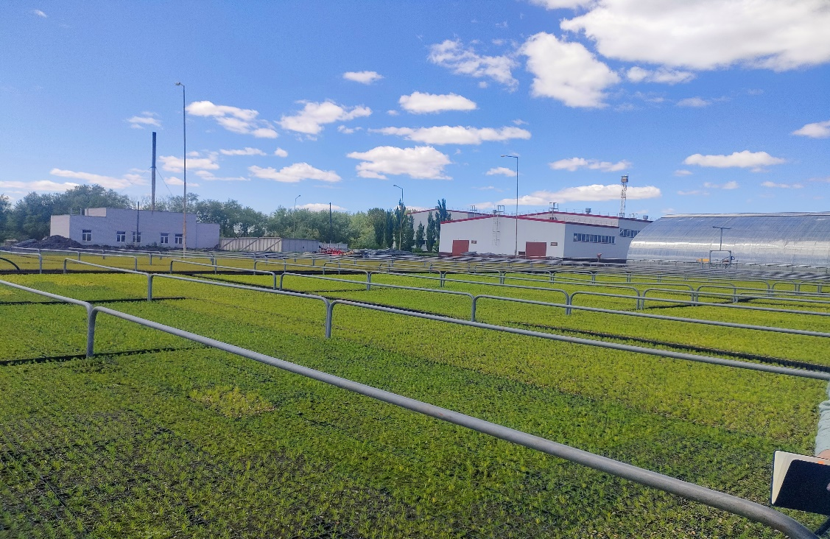The Kanonerka forest and seed complex (Figure 1), located in the village of Kara-Murza in the Beskaragai district of the Abai region, is a unique facility.

Figure 1 - The Kanonerka forest-seed complex

* **Features of the complex's operation:**
* • Growing method: the method of closed soil in cells is used, which ensures almost 100% survival rate of seedlings. Half-year-old seedlings are planted with a clod of earth, preserving the necessary minerals and nutrients for further development.
* • Garden area: the area planted with pine trees is 20.4 hectares.
* • Staff: 26 employees are involved in the nursery care and planting of new seedlings, as well as 20 temporary workers each season.
* At the first stage, soil preparation was carried out (Figure 2). Vermicompost was used as fertilizer, which was applied to the soil before sowing. Next, two experimental groups were identified:
* 1. The first group is the sowing of pine seeds in soil enriched with vermicompost.
* 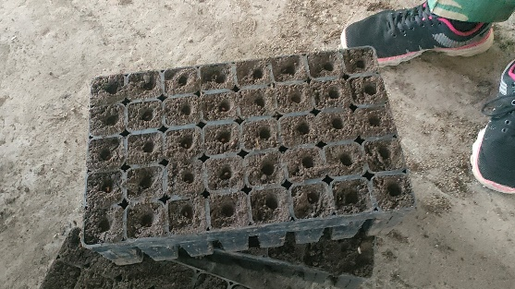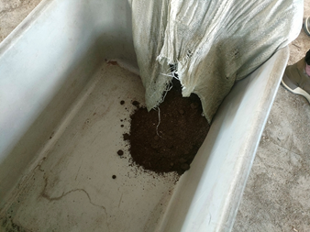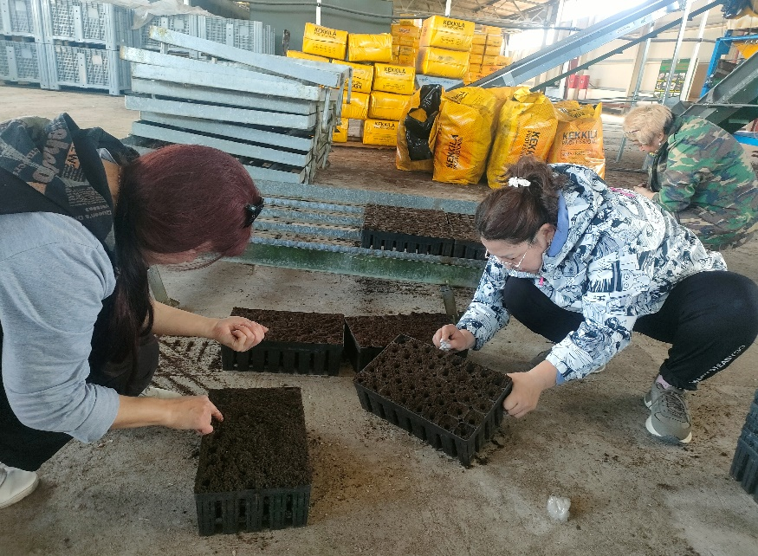 The second group is sowing seeds in Kekkila peat (Finnish producer), which contains peat minerals and organic substances.

Figure 2 - Soil preparation and sowing of seeds in the Kanonerka nursery

During the experiment, 8 cassettes were seeded, each of which contained 25 wells. Thus, 200 pine seedlings were sown in the trial cassettes. Since two types of soil were studied, a total of 400 seedlings were sown.

**The first results of observations**

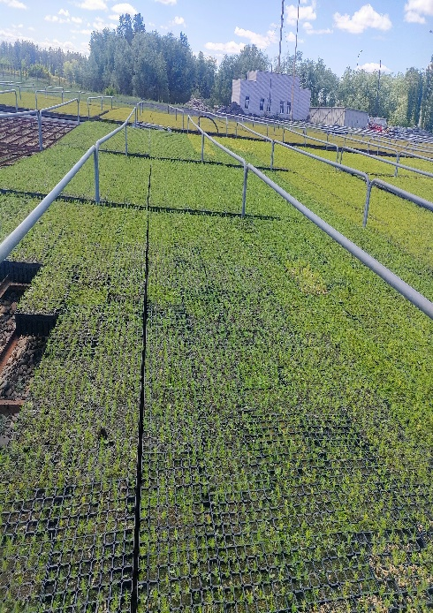Some time after the sowing, the first field surveys were conducted. It was noted that seedlings appeared in all groups, but seedlings grown on Kekkila peat had a healthier appearance (Figures 3, 4). They were distinguished by their rich green color, strong stems and uniform development. In comparison with the control group, their growth was more uniform, and there were also better phenological indicators.

Figure 3- Gunboat nursery-objects of research/1

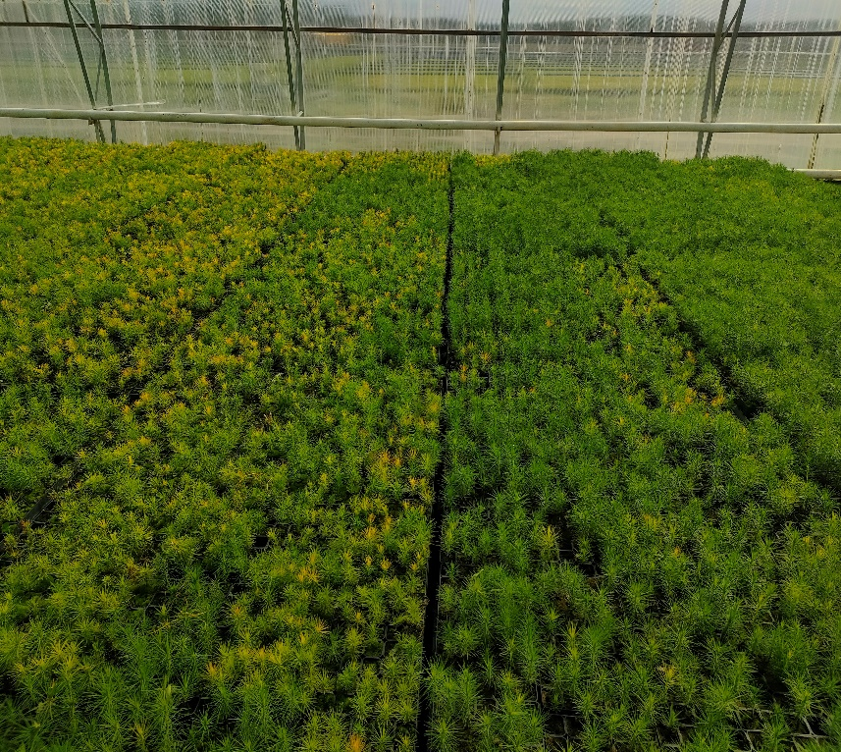

Figure 4- Gunboat nursery-objects of research/2

**Comparative analysis**

Based on phenological observations, it can be concluded that the addition of peat minerals to the soil has a positive effect on the development of seedlings (Figure 5). The main differences between the groups were as follows:

• Seedlings on Kekkila peat had a more developed root system.

• Visually, a large growth force, density and uniformity of plant development were observed.

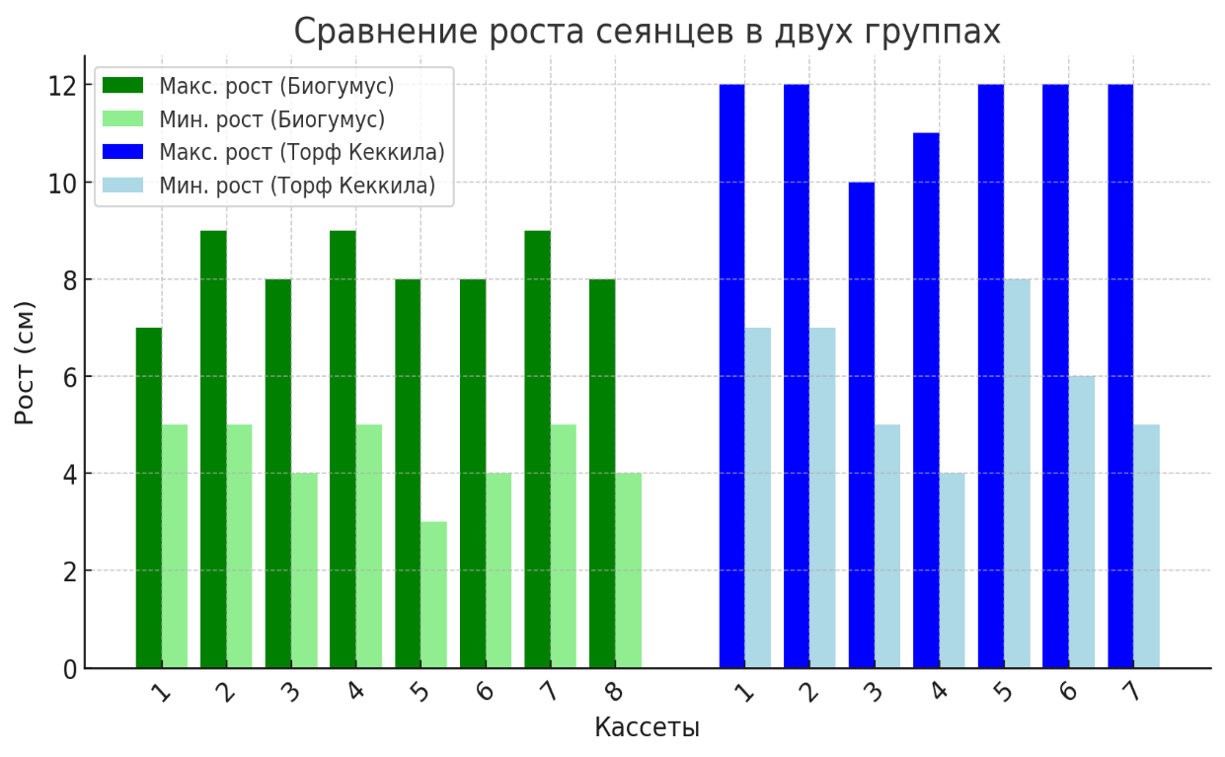• The probability of damage by diseases and adverse factors in plants in the second group was lower.

Table 3 – comparative analysis in tabular form

| Parameters | Vermicompost | Kekkila Peat | Difference |
| --- | --- | --- | --- |
| Maximum height (cm) | 9 | 12 | +3 см |
| Minimum height (cm) | 3 | 4 | +1 см |
| Average maximum height (cm) | 8.25 | 11.57 | +3.32 см |
| Average minimum height (cm) | 4.38 | 6.00 | +1.62 см |
| Ungrown seedlings (pcs.) | 39 | 21 | -18 |
| Dead seedlings (pcs.) | 3 | 0 | -3 |
| Diseased seedlings (pcs.) | 1 | 0 | -1 |

Growing Kekkila on peat gives the best results in the growth, survival rate and health of seedlings.

During the experiment, the indicators of survival, stability and growth rates of pine seedlings were studied using two types of substrates: soil fertilized with vermicompost and Kekkila peat. The data obtained make it possible to evaluate the effectiveness of each of the options and draw conclusions about the effect of fertilizers on plant adaptation.

Assessment of the effect of fertilizers on the survival and adaptation of pine seedlings

During the experiment, the indicators of survival, stability and growth rates of pine seedlings were studied using two types of substrates: soil fertilized with vermicompost and Kekkila peat. The data obtained make it possible to evaluate the effectiveness of each of the options and draw conclusions about the effect of fertilizers on plant adaptation.

**Analysis of the survival rate of seedlings**

 Survival rate was determined by the formula:

(1)

where:

P is the survival rate (%),

N is the total number of seeds sown (400),

N not sprouted — the number of seeds that did not germinate.

Calculation results:

A group with vermicompost:

(2)

Kekkila Peat Group:

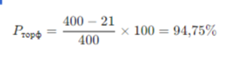  
(3)

The use of Kekkila peat contributed to a 4.5% increase in survival rate compared to vermicompost, which may indicate more favorable conditions for germination and rooting of seedlings.

Seedling losses and stress tolerance

To assess stress resistance, the number of plants that did not grow and died was analyzed.:,

• Vermicompost: 39 did not grow + 3 died → 42 lost seedlings.

• Kekkila peat: 21 did not grow + 0 died → 21 lost seedlings.

Thus, Kekkila peat provided two times less loss of planting material, which indicates a more beneficial effect on the development of seedlings and their ability to adapt to growing conditions.

The effect of fertilizers on the growth of seedlings

The average growth rates of seedlings in different versions of the experiment:

| Indicator | Vermicompost (cm) | Kekkila peat (cm) | Difference (cm) |
| --- | --- | --- | --- |
| Average maximum height | 8.25 | 11.57 | +3.32 |
| Average minimum height | 4.38 | 6.00 | +1.62 |

Seedlings grown on Kekkila peat showed more intensive growth and high phenological activity, which may be due to improved moisture retention and the presence of a balanced complex of trace elements.

**Conclusion**

Preliminary results show that the use of peat minerals improves the growth and development of pine seedlings. In the future, it is planned to continue observations to determine the long-term effect of the use of peat additives and their effect on the adaptation of seedlings in the open ground.

The analysis of experimental data allows us to draw the following conclusions:

1. Kekkila peat provided a high survival rate (94.75% versus 90.25% for vermicompost), which indicates the beneficial effect of the substrate on germination and rooting of seedlings.

2. Losses of planting material in the group with Kekkila peat were two times lower than in the group with vermicompost, which indicates a lower stress level in plants.

3. The growth rates of seedlings on Kekkila peat were significantly higher, which confirms its positive effect on the phenological development of plants.

Thus, the use of Kekkila peat promotes better adaptation and growth of pine seedlings compared to vermicompost. Further research may be aimed at studying the combined use of these fertilizers to optimize the growing conditions of the planting material.

**Список литературы:**

1. Белоусова, Е. В. Влияние органических удобрений на рост и развитие лесных культур // Лесоведение. – 2020. – № 4. – С. 45–52.
2. Васильев, П. А. Торфяные субстраты и их использование в лесных питомниках // Лесное хозяйство. – 2019. – № 6. – С. 78–85.
3. Головин, С. В. Биогумус как фактор повышения приживаемости сеянцев хвойных пород // Почвоведение. – 2021. – № 3. – С. 112–118.
4. Дмитриев, И. Н. Влияние торфяных добавок на агрохимические свойства почвы и рост растений // Агрохимия. – 2018. – № 5. – С. 34–40.
5. Захарова, Т. А. Использование компостов в лесных питомниках: экологические и экономические аспекты // Лесной вестник. – 2022. – № 2. – С. 21–29.
6. Иванова, М. В., Сидоров, Л. Г. Методы оценки фенологических показателей саженцев сосны // Экология растений. – 2017. – № 8. – С. 63–71.
7. Климов, А. Ю. Компостирование органических отходов и их влияние на почвенное плодородие // Агроэкология. – 2020. – № 1. – С. 92–100.
8. Лесников, В. П. Современные технологии выращивания посадочного материала сосны // Лесоводство и агролесомелиорация. – 2021. – № 9. – С. 55–64.
9. Михайлова, О. С. Влияние различных типов торфа на рост саженцев хвойных пород // Лесное хозяйство и экология. – 2019. – № 7. – С. 84–90.
10. Николаев, Д. В. Использование биогумуса в лесных питомниках: преимущества и недостатки // Современные проблемы лесоведения. – 2022. – № 5. – С. 31–38.
11. Орлов, Е. Ф. Адаптация саженцев сосны к различным типам почв и удобрений // Лесные экосистемы. – 2018. – № 6. – С. 109–117.
12. Петрова, А. Н. Влияние субстратов на рост и развитие корневой системы лесных культур // Биоэкология. – 2020. – № 3. – С. 41–49.
13. Романов, Ю. В. Эффективность использования торфяных удобрений в лесном хозяйстве // Лесоведение. – 2021. – № 10. – С. 72–80.
14. Соловьёв, К. Н. Влияние органоминеральных субстратов на фенологические показатели хвойных растений // Лесная наука. – 2019. – № 2. – С. 57–66.
15. Шевченко, В. Д. Почвенные условия и технологии выращивания сеянцев сосны в питомниках // Лесное хозяйство и экология. – 2023. – № 4. – С. 99–106.

**List of literature:**

1. Belousova, E. V. The influence of organic fertilizers on the growth and development of forest crops // Forestry science. 2020. No. 4. pp. 45-52.

2. Vasiliev, P. A. Peat substrates and their use in forest nurseries // Forestry. 2019. No. 6. pp. 78-85.

3. Golovin, S. V. Vermicompost as a factor in increasing the survival rate of coniferous seedlings // Soil Science. – 2021. – No. 3. – pp. 112-118.

4. Dmitriev, I. N. Influence of peat additives on agrochemical properties of soil and plant growth // Agrochemistry. - 2018. – No. 5. – pp. 34-40.

5. Zakharova, T. A. The use of compost in forest nurseries: ecological and economic aspects // Lesnoy vestnik. – 2022. – No. 2. – pp. 21-29.

6. Ivanova, M. V., Sidorov, L. G. Methods for assessing phenological parameters of pine seedlings // Plant Ecology, 2017, No. 8, pp. 63-71.

7. Klimov, A. Y. Composting of organic waste and its effect on soil fertility // Agroecology. – 2020. – No. 1. – pp. 92-100.

8. Lesnikov, V. P. Modern technologies for growing pine planting material // Forestry and agroforestry. - 2021. – No. 9. – pp. 55-64.

9. Mikhailova, O. S. The influence of various types of peat on the growth of coniferous seedlings // Forestry and ecology. – 2019. – No. 7. – pp. 84-90.

10. Nikolaev, D. V. The use of vermicompost in forest nurseries: advantages and disadvantages // Modern problems of forest science. – 2022. – No. 5. – pp. 31-38.

11. Orlov, E. F. Adaptation of pine seedlings to various types of soils and fertilizers // Forest ecosystems. - 2018. – No. 6. – pp. 109-117.

12. Petrova, A. N. The influence of substrates on the growth and development of the root system of forest crops // Bioecology. - 2020. – No. 3. – pp. 41-49.

13. Romanov, Yu. V. Efficiency of peat fertilizers use in forestry // Forestry Science. – 2021. – No. 10. – pp. 72-80.

14. Solovyov, K. N. Influence of organomineral substrates on phenological parameters of coniferous plants // Lesnaya nauka. 2019. No. 2. pp. 57-66.

15. Shevchenko, V. D. Soil conditions and technologies for growing pine seedlings in nurseries // Forestry and Ecology. - 2023. – No. 4. – pp. 99-106.

***О.Адалкан1*, Г.И. Джаманова1, Ж.М. Байгазакова 1, К. Ю. Дербышев2, М.К. Булатова3***

*1* НАО «Университет имени Шакарима города Семей» Абайской области, г. Cемей, ул.Глинки 20А, 071412, Казахстан,* [*oral.adalkan@mail.ru*](mailto:oral.adalkan@mail.ru)

***2\**** *Агротехнопарк НАО «Университет имени Шакарима города Семей» Абайской области, г. Cемей, ул.Глинки 20А, 071412, Казахстан.*

*3 РГУ ГЛПР «Семей Орманы», Семей, ул. Туктабаева, 19, Казахстан.*

**ВЛИЯНИЕ КОМПОСТА С ДОБАВЛЕНИЕМ ТОРФЯНЫХ МИНЕРАЛОВ НА РОСТ СЕЯНЦЕВ СОСНЫ**

***Аннотация***

*В статье рассматривается влияние компоста с добавлением торфяных минералов на рост и выживаемость сеянцев сосны обыкновенной (Pinus sylvestris) в лесных питомниках. Исследования показали, что использование органических удобрений, обогащённых торфяными компонентами, способствует улучшению структуры почвы, повышению содержания гумуса и микроэлементов, необходимых для полноценного развития корневой системы. В ходе экспериментов изучались различные пропорции компоста и торфяных добавок, а также проводилась сравнительная оценка роста сеянцев и их биомассы. Результаты показывают, что совместное использование этих компонентов повышает выживаемость саженцев на 4,5%, снижает потери посадочного материала в 2 раза и ускоряет рост растений на 3–4 см. Улучшенная аэрация и влагоудерживающая способность почвы способствовали повышению устойчивости растений к стрессовым факторам.*

*Кроме того, фенологический анализ показал, что саженцы, выращенные с добавлением торфяных минералов, имели более развитую корневую систему и активно наращивали биомассу. Полученные результаты подтверждают целесообразность использования этой технологии в лесных питомниках и проектах по восстановлению лесов, поскольку она не только повышает урожайность саженцев, но и способствует созданию экологически устойчивых лесных насаждений. Разработанные рекомендации могут быть использованы для дальнейшей оптимизации субстратов и улучшения методов посадки, что особенно важно в условиях изменения климата и деградации почв.*

***Ключевые слова:*** *сосна обыкновенная, саженцы, лесные питомники, компост, торф, минералы, удобрения, органические добавки, рост растений, плодородие почвы, гумус, биомасса, аэрация почвы, минерализация, микробиологическая активность, корневое питание, адаптация растений, устойчивость к стрессам, инновационные удобрения, экология леса, восстановление почвы, структура почвы, эффективность удобрений, ускоренный рост, защита от болезней, лесовосстановление, лесное хозяйство.*

***О.Адалқан1*, Г.И. Джаманова1, Ж.М. Байгазакова 1, К. Ю. Дербышев2, М.К. Булатова3***

*1* "Семей қаласының Шәкәрім атындағы университеті" КЕАҚ, Абай облысы, Семей қ., Глинка к-сі 20а, 071412, Қазақстан,* [*oral.adalkan@mail.ru*](mailto:oral.adalkan@mail.ru)

***2\**** *"Семей қаласының Шәкәрім атындағы университеті" КЕАҚ агротехнопаркі, Абай облысыСемей қаласы, Глинка көшесі 20а, 071412, Қазақстан.*

*3 МОТР РММ «Семей Орманы», Семей, Туктабаева 19, Казахстан.*

**ШЫМТЕЗЕК МИНЕРАЛДАРЫ ҚОСЫЛҒАН КОМПОСТТЫҢ ҚАРАҒАЙ КӨШЕТТЕРІНІҢ ӨСУІНЕ ӘСЕРІ**

***Аннотация***

*Мақалада шымтезек минералдары қосылған компосттың орман питомниктеріндегі кәдімгі қарағай көшеттерінің (Pinus sylvestris) өсуі мен өмір сүруіне әсері қарастырылады. Зерттеулер шымтезек компоненттерімен байытылған органикалық тыңайтқыштарды қолдану топырақ құрылымын жақсартуға, тамыр жүйесінің толық дамуы үшін қажетті қарашірік пен микроэлементтердің мөлшерін арттыруға ықпал ететінін көрсетті. Эксперименттер компост пен шымтезек қоспаларының әртүрлі пропорцияларын зерттеді, сонымен қатар көшеттердің өсуі мен олардың биомассасын салыстырмалы бағалау жүргізілді. Нәтижелер бұл компоненттерді бөлісу көшеттердің өмір сүру деңгейін 4,5% - ға арттыратынын, отырғызу материалының жоғалуын 2 есе азайтатынын және өсімдіктердің өсуін 3-4 см жылдамдататынын көрсетеді.*

*Сонымен қатар, фенологиялық талдау шымтезек минералдарын қосып өсірілген көшеттердің тамыр жүйесі дамыған және биомассаны белсенді түрде өсіретінін көрсетті. Нәтижелер бұл технологияны орман питомниктерінде және ормандарды қалпына келтіру жобаларында қолданудың орындылығын растайды, өйткені ол көшеттердің өнімділігін арттырып қана қоймайды, сонымен қатар экологиялық тұрақты орман екпелерін құруға ықпал етеді. Әзірленген нұсқаулар субстраттарды одан әрі оңтайландыру және отырғызу әдістерін жақсарту үшін пайдаланылуы мүмкін, бұл әсіресе климаттың өзгеруі мен топырақтың деградациясы жағдайында маңызды.*

***Kілт сөздер:*** *кәдімгі қарағай, көшеттер, орман питомниктері, компост, шымтезек, минералдар, тыңайтқыштар, органикалық қоспалар, өсімдіктердің өсуі, топырақ құнарлылығы, гумус, биомасса, топырақ аэрациясы, минералдану, микробиологиялық белсенділік, тамыр қоректенуі, өсімдіктердің бейімделуі, стресске төзімділік, инновациялық тыңайтқыштар, орман экологиясы, топырақты қалпына келтіру, топырақ құрылымы, тиімділігі тыңайтқыштар, жедел өсу, аурулардан қорғау, ормандарды қалпына келтіру, орман шаруашылығы.*

**Сведения об авторах**

**Адалкан О**., магистр сельскохозяйственных наук, <https://orcid.org/0000-0003-0010-9762>, НАО «Университет имени Шакарима города Семей» Абайской области, г. Cемей, ул.Глинки 20А, 071412, Казахстан, [oral.adalkan@mailru](mailto:oral.adalkan@mailru)

**Джаманова Г.И.,** кандидат сельскохозяйственных наук, и.о.доцента, НАО Университета Шакарим г. Семей [dzhamanovag@bk.ru](mailto:dzhamanovag@bk.ru)

**Байгазакова Ж.М.** – PhD, преподаватель кафедры «Сельское хозяйство» ; Университет имени Шакарима города Семей, Республика Казахстан; e-mail: [jadi-2-92@mail.ru](mailto:jadi-2-92@mail.ru). ORCID: <https://orcid.org/0000-0003-3664-8258>.

**Дербышев К.Ю.,** Старший научный сотрудник Агротехнопарка НАО «Университет имени Шакарима города Семей», 0000-0002-6308-020X, [derbyshev_kamil@mail.ru](mailto:derbyshev_kamil@mail.ru)

**Булатова М.К.,** руководитель отдела науки и мониторинга РГУ ГЛПР «Семей орманы», г.Семей, ул. Туктабаева 19, Казахстан, [marsi.7@mail.ru](mailto:marsi.7@mail.ru)

**Information about the authors**

**Adalkan O.,** Master of Agricultural Sciences, <https://orcid.org/0000-0003-0010-9762> , Non-commercial joint-stock company "Shakarim Semey University" of the Abai region, Semey, Glinka str. 20A, 071412, Kazakhstan, [oral.adalkan@mailru](mailto:oral.adalkan@mailru)

**Dzhamanova G.I.,** Candidate of Agricultural Sciences, Acting Associate Professor, Non-commercial joint-stock company "Shakarim Semey University" of the Abai region, Semey, Glinka str. 20A, 071412, Kazakhstan, [dzhamanovag@bk.ru](mailto:dzhamanovag@bk.ru)

**Baigazakova Zh.M. –** PhD, lecturer at the Department of Agriculture ; Shakarim University of Semey, Republic of Kazakhstan; e-mail: jadi-2-92@mail.ru . ORCID: <https://orcid.org/0000-0003-3664-8258>

**Derbyshev K.Yu.,** Senior Researcher at the Agrotechnopark of the Non-commercial joint-stock company "Shakarim University of Semey", 0000-0002-6308-020X, [derbyshev_kamil@mail.ru](mailto:derbyshev_kamil@mail.ru)

**Bulatova M.K.,** *Republican State Institution State Forest Natural Reserve* "Semey Ormany", Semey, 19 Tuktabayeva St., Kazakhstan, [marsi.7@mail.ru](mailto:marsi.7@mail.ru)

**Авторлар туралы мәліметтер**

**Адалқан О.,** ауыл шаруашылығы ғылымдарының магистрі, <https://orcid.org/0000-0003-0010-9762>, Абай облысының "Семей қаласының Шәкәрім атындағы университеті" КЕАҚ, Семей қ., Глинка к-сі 20а, 071412, Қазақстан, [oral.adalkan@mailru](mailto:oral.adalkan@mailru)

**Джаманова Г.И.,** Ауыл Шаруашылығы Ғылымдарының Кандидаты, Доцент, "Шәкәрім Атындағы Семей Университеті" КЕАҚ, [dzhamanovag@bk.ru](mailto:dzhamanovag@bk.ru)

**Байгазакова Ж. М. -** PhD, "Ауыл шаруашылығы" кафедрасының оқытушысы ; Семей қаласының Шәкәрім атындағы университеті, Қазақстан Республикасы; E-mail: jadi-2-92@mail.ru. ORCID: <https://orcid.org/0000-0003-3664-8258>.

**Дербышев К.Ю.**, "Семей қаласының Шәкәрім атындағы университеті" КЕАҚ Агротехнопаркінің аға ғылыми қызметкері, 0000-0002-6308-020, [derbyshev_kamil@mail.ru](mailto:derbyshev_kamil@mail.ru)

**Булатова М. К**., "Семей орманы" МОТР РММ ғылым және мониторинг бөлімінің басшысы, Семей қ., Туктабаев к-сі, 19, Қазақстан, [marsi.7@mail.ru](mailto:marsi.7@mail.ru)